Analysis Level Class Diagrams

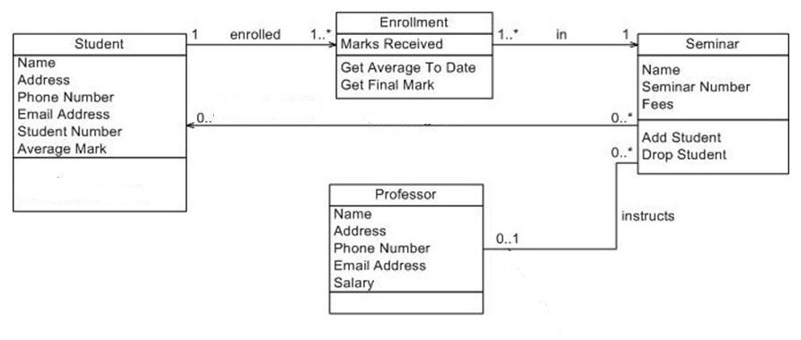

Figure : Analysis Level Class Diagram

*Note: this is just an example. Replace it with appropriate diagram*